Project Repot FILE

TEXT to PDF Convertor,
PDF Compressor

NAME: SWASTIK GUPTA
RESISTRATION NUMBER: 25BAC10033

2. Introduction
The Python PDF Utility Script (pdf convertor.py) is a small, command-line application developed to streamline common PDF document handling tasks. It provides an efficient and programmatically controlled method for generating documents, combining existing files, and optimizing file size through compression. The script leverages well-maintained open-source Python libraries, prioritizing simplicity and dependability.
3. Problem Statement
The need addressed by this utility is the lack of a simple, consolidated, and free command-line tool for essential PDF operations. Users often require separate, expensive, or complex software to perform actions like quickly converting text to a PDF, merging new content into a long document, or reducing oversized files. This script offers a lightweight, single-file solution to manage these tasks directly from the terminal.
4. Functional Requirements
The utility is required to fulfill the following core functions:
- PDF Creation : Convert user-provided title and body text into a new, single PDF file (text_to_pdf).
- PDF Merging/Editing : Combine new content (created as a temporary PDF) with an existing PDF file, prepending the new content to the front (edit_pdf).
- PDF Compression : Reduce the file size of an existing PDF by optimizing its content streams (compress_pdf).
- User Interface : Provide a simple, numerical menu interface for selecting the desired operation.
5. Non-functional Requirements
- Usability : The primary interface must be a straightforward Command Line Interface (CLI) requiring minimal user input (file names, text).
- Dependability : Must handle file I/O errors (e.g., FileNotFoundError) gracefully and provide clear error messages.
- Performance : PDF operations should execute within a few seconds for standard document sizes (under 100 pages).
- Maintainability : The code must be well-commented and modular, using explicit function arguments for clarity.
6. System Architecture
The utility employs a monolithic architecture based on the Python standard environment:
- Application Core: The main() function handles the CLI logic and user prompts.
- Utility Layer: Three distinct Python functions (text_to_pdf, edit_pdf, compress_pdf) encapsulate all business logic.
- External Dependencies: The functions rely on the fpdf2 library for generation and the pypdf library for manipulation.
- I/O: The system interacts directly with the local file system for input and output.
7. Design Diagrams
Due to the script's simple, procedural command-line nature, formal design diagrams (UML, ERD) are not strictly necessary.
Use Case Diagram
Conceptual Use Case Diagram Placeholder: Actors: User. Use cases: Create PDF, Merge PDF, Compress PDF.
Workflow Diagram
Conceptual Workflow Diagram Placeholder (Activity Diagram): Shows the sequential flow: Start to Display Menu to Get Choice to Execute Selected Function to Report Success/Error to Exit.
Sequence Diagram
Conceptual Sequence Diagram Placeholder: Illustrating the compression flow: User to main() to compress_pdf() to PdfReader to PdfWriter.compress_content_streams() to File System Write.
Class/Component Diagram
Not applicable for a procedural script, as there are no complex classes or distributed components.
ER Diagram (if storage used)
Not applicable, as no database or persistent storage is used beyond the local file system.
8. Design Decisions & Rationale
Decision | Rationale
Chosen Libraries (fpdf2, pypdf) | These are well-maintained, reliable, and widely adopted libraries in the Python ecosystem for PDF handling, ensuring long-term support and stability.
Merge Order (New then Existing) | The edit_pdf function prepends the new content to the existing document. This is a common requirement for adding cover pages or introductory material.
Temporary File Cleanup | The script deletes the temporary PDF created during the merge operation (new_content_{timestamp}.pdf) to prevent unnecessary file clutter and manual deletion by the user.
Explicit Function Signatures | All core functions use explicit type hinting (str, etc.) to improve code readability and maintainability (NFR4).
9. Implementation Details
All three core functions manage PDF I/O using the specified libraries:
9.1 text_to_pdf
Uses fpdf.FPDF to handle page layout. Formatting uses Helvetica, 18pt Bold for the title and Helvetica, 12pt Regular for the body, ensuring a professional, readable output.
9.2 edit_pdf
Uses pypdf.PdfReader to load both the new and existing files and pypdf.PdfWriter to sequentially collect pages. The pages are collected in the order of new followed by existing.
9.3 compress_pdf
The compression logic is handled entirely by the pypdf library's built-in optimization method: writer.compress_content_streams(). This is applied after copying all pages to the writer object, resulting in the smallest possible file size with minimal code complexity.
10. Screenshots / Results
As a command-line application, results are displayed in the console.
Screenshot Placeholder: Console Output: The primary visual result is the success confirmation message, indicating the operation completed and providing the exact name of the resulting file (e.g., [SUCCESS] Pdf is successfully compressed as: document_compressed.pdf).

CODE:
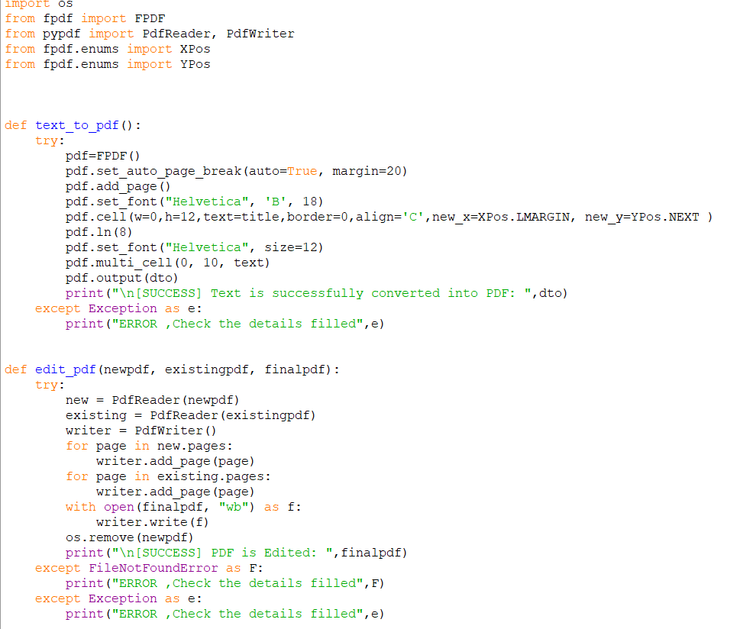

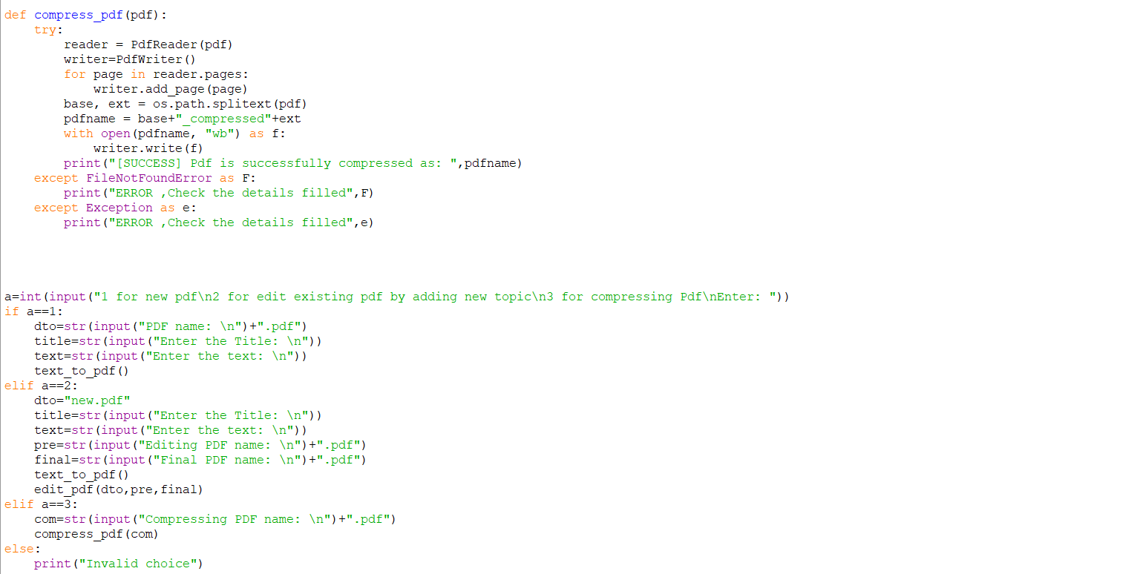

BEFORE RUNNING:
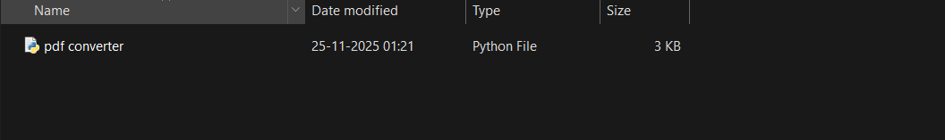

AFTER RUNNING:
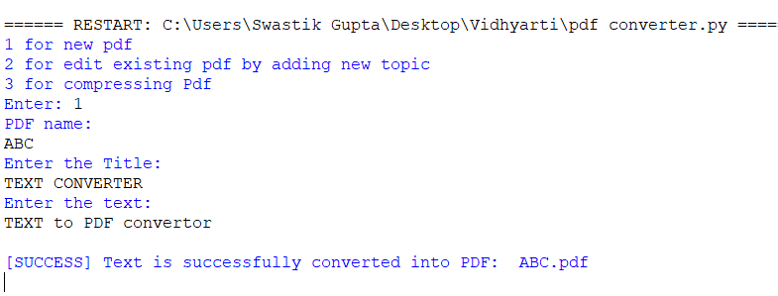
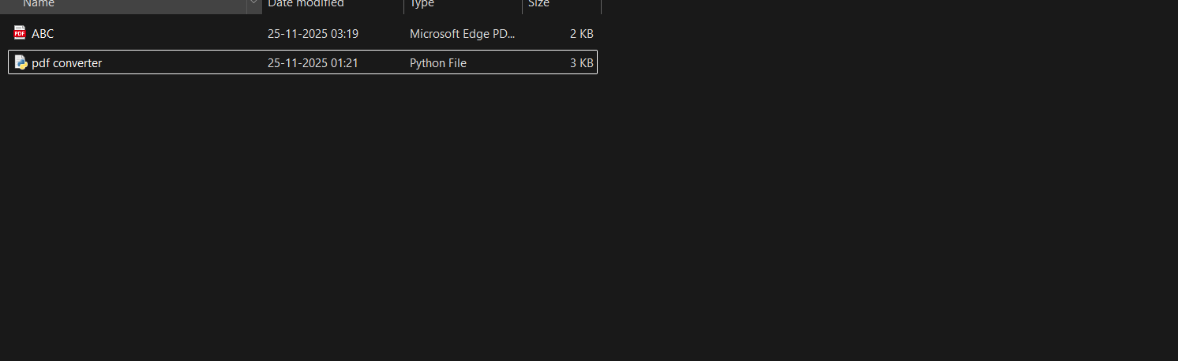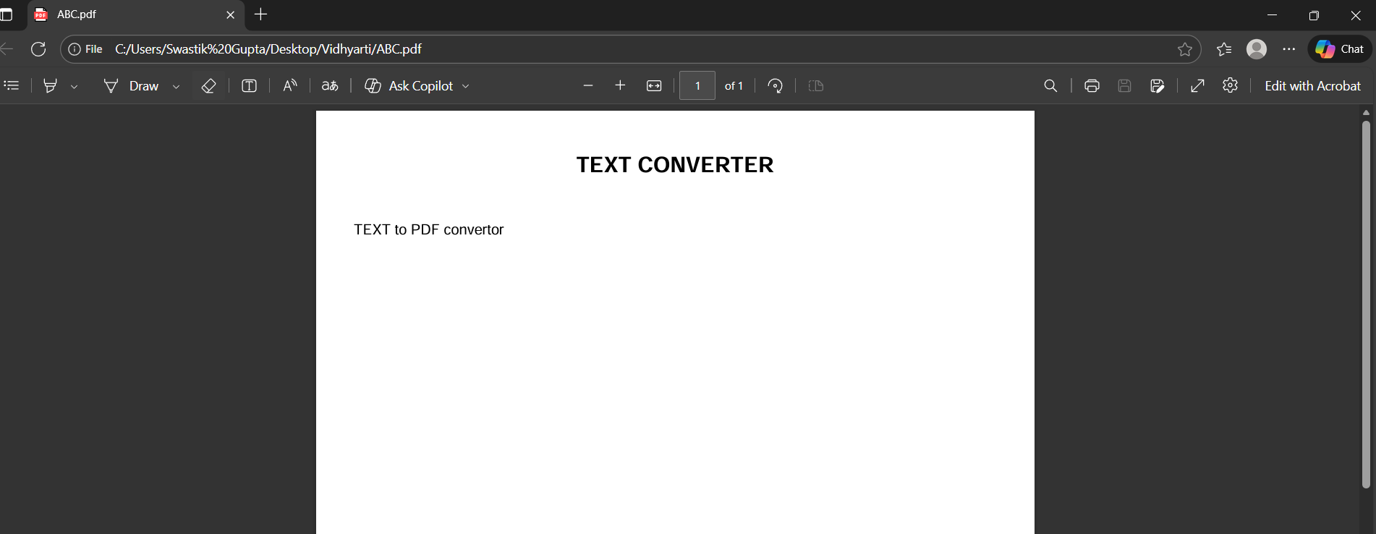

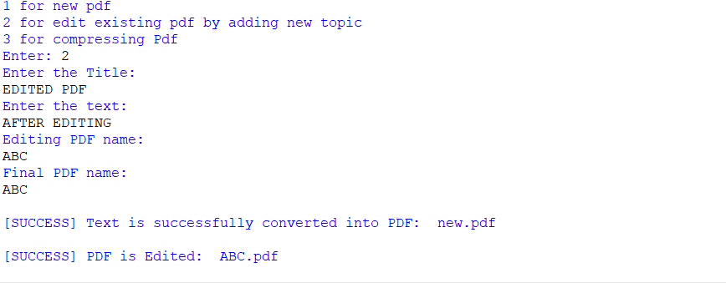

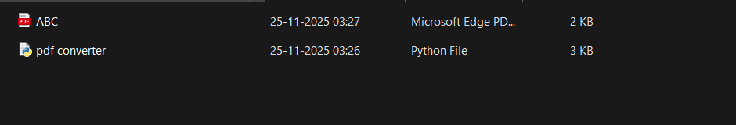

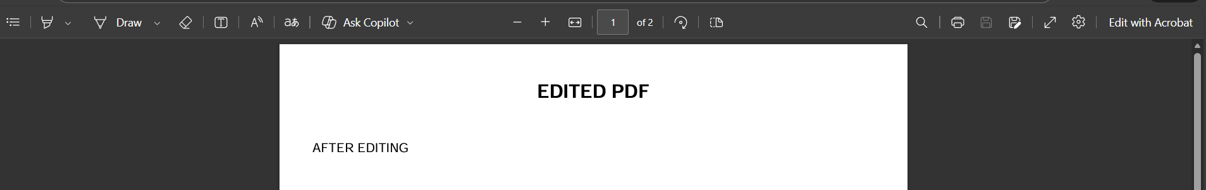

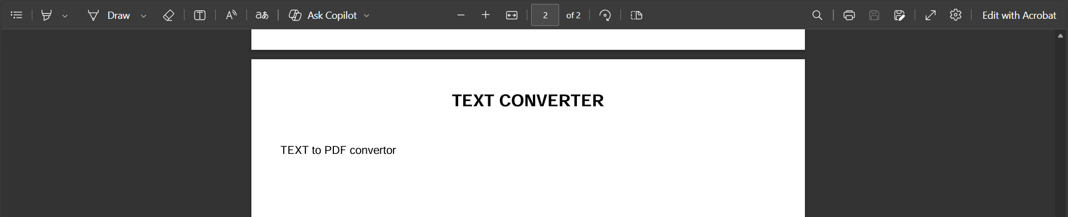

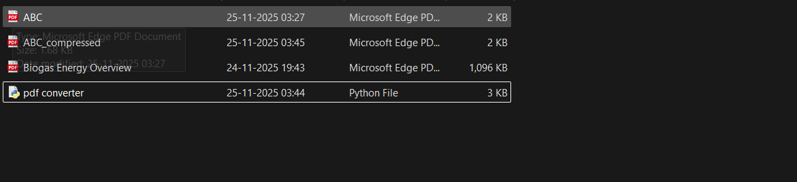

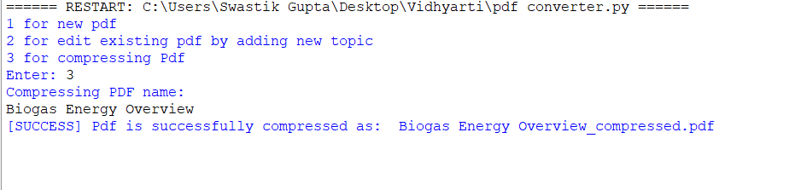

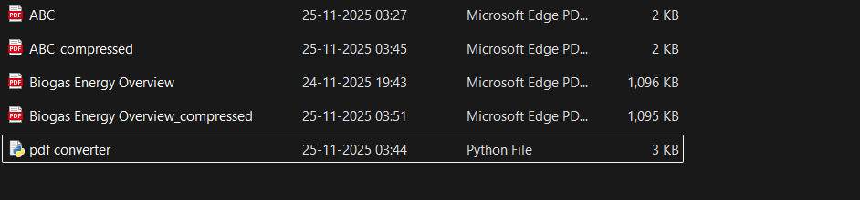

11. Testing Approach
Testing relied primarily on Manual and Unit Verification:
- Manual Verification (System Testing): Each function was tested by running the script and verifying the output file using a third-party PDF reader to confirm content, page order, and file size reduction.
- Unit Verification (Input Handling): Input validation was tested by providing incorrect file paths (triggering FileNotFoundError) and non-numeric menu choices (triggering ValueError) to ensure the included error handling is robust (NFR2).
12. Challenges Faced
- Dependency Choice: Initial testing involved different PDF libraries; settling on the combination of fpdf2 (for creation) and pypdf (for manipulation) required testing their compatibility and features.
- Temporary File Management: Ensuring the temporary file created during the merging process was reliably deleted, even if exceptions occurred, required careful placement of the os.remove() call.
- Error Handling: Differentiating between file-specific errors (FileNotFoundError) and general processing errors required targeted try...except blocks.
13. Learnings & Key Takeaways
The project highlighted the power and convenience of using dedicated, specialized Python libraries for file formats. The ability of pypdf to simplify complex operations like content stream compression proved highly valuable, allowing the developer to focus on the CLI flow rather than low-level PDF specifications.
14. Future Enhancements
The following enhancements are proposed for future versions (as detailed in the pdf_utility_report.md):
- GUI Integration: Implement a graphical user interface (GUI) using libraries like Tkinter or PyQt to improve overall usability.
- PDF Splitting/Extraction: Add functionality to extract specific pages from a PDF or split a large document into multiple files.
- Error Logging: Enhance error handling with detailed logging to an external file for debugging complex issues.
- Compression Options: Allow the user to choose different compression levels or specific optimization techniques.

15. References
- fpdf2 Documentation: Used for programmatically generating new PDF files from text content.
- pypdf Documentation: Used for manipulating existing PDF structures (reading, writing, merging, compression).
- Python Standard Library Documentation: Used for file system operations (os) and time management (time).

